**Confusion Matrix**

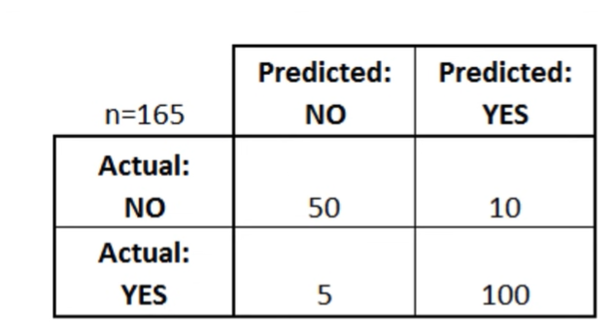

**If we were predicting the presence of a disease, for example “Yes” would mean they have the disease, and “no” would mean they don’t have the disease.**

1. **Calculate, how often is the classifier correct. [ Accuracy ]**

Accuracy = (Actual No & Predicted No) + (Actual Yes + Predicted Yes) / n

= (50+100)/165 = 0.9091 = 90.91%

1. **Calculate, how often is it wrong [ Misclassification Rate / Error Rate ]**

Error Rate = (Actual No & Predicted Yes) + (Actual Yes & Predicted No)/n

= (10+5)/165 = 0.909 = 9.09%

1. **When it’s actually yes, how often does it predict yes ? [ True Positive Rate / Recall ]**

Recall = (Actual Yes + Predicted Yes) / (Actual Yes + Predicted Yes)+ (Actual No & Predicted Yes)

= 100 / (100+10) = 100/110 = 0.9091 = 90.91%

1. **When it’s actually no, how often does it predict yes ? [False Positive Rate / Specificity]**

Specificity = (Actual No & Predicted No) / ((Actual No & Predicted No)+ (Actual Yes & Predicted No))

= 50 /(50+5) = 0.9091 = 90.91%